**CRYPTOCURRENCY PREDICTION**

**A PROJECT REPORT**

***Submitted By***

**Varanasi Hemasai Reddy (21MIM10056)**

**Tanishq Kolhatkar (21MIM10025)**

**Veera Venkata Vikas (21MIM10062)**

**Sameer Sheikh (21MIM10077)**

*in partial fulfillment for the award of the degree*

*of*

**INTEGRATED MASTER OF TECHNOLOGY**

*in*

**COMPUTER SCIENCE AND ENGINEERING**

**SPECIALIZATION IN ARTIFICIAL INTELLIGENCE AND**

**MACHINE LEARNING**



**SCHOOL OF COMPUTING SCIENCE AND ENGINEERING**

**VIT BHOPAL UNIVERSITY**

**KOTHRIKALAN, SEHORE**

**MADHYA PRADESH – 466114**

SEP 2022

**VIT BHOPAL UNIVERSITY, KOTHRIKALAN, SEHORE**

**MADHYA PRADESH – 466114**

**BONAFIDE CERTIFICATE**

Certified that this project report titled **“Cryptocurrency Prediction”** is the bonafide work of **“Tanishq Kolthkar (21MIM10025), Varanasi Hemasai Reddy(21MIM10056), Veera Venkata Vikas(21MIM10056), Sameer Sheikh(21MIM10077)”** who carried out the project work under my supervision. Certified further that to the best of my knowledge the work reported at this time does not form part of any other project/research work based on which a degree or award was conferred on an earlier occasion on this or any other candidate.

**PROGRAM CHAIR PROJECT GUIDE**

Dr. A.V.R Mayuri Dr. Siddarth Singh Chauhan

School of Computer Science and Engineering School of Computer Science and Engineering

Integrated MTech CSE (AI and ML) Assistant Professor

VIT BHOPAL UNIVERSITY VIT BHOPAL UNIVERSITY

The Project Exhibition I Examination is held on …......... 2022

**ACKNOWLEDGEMENT**

First and foremost, I would like to thank the Lord Almighty for His presence and immense blessings throughout the project work.

I wish to express my heartfelt gratitude to **Dr. A.V.R Mayuri**, Head of the Department (CDS), School of Computer Science and Engineering for much of his valuable support and encouragement in carrying out this work.

I would like to thank my internal guide **Dr. Siddarth Singh Chauhan** and **Dr. A.V.R Mayuri**, for continually guiding and actively participating in my project, giving valuable suggestions to complete the project work.

I would like to thank all the technical and teaching staff of the School of Computer Science and Engineering, who extended directly or indirectly all support.

Last, but not least, I am deeply indebted to my parents who have been the greatest support while I worked day and night for the project to make it a success.

**LIST OF ABBREVIATIONS**

|  |  |  |
| --- | --- | --- |
| **S.no** | **Abbreviation** | **Definition** |
| **1** | LSTM | Long Short-Term Memory |
| **2** | RNN | [Recurrent neural network](https://en.wikipedia.org/wiki/Recurrent_neural_network) |
| **3** | RMSE | Root Mean Square Error |
| **4** | MAE | Mean Absolute Error |
| **5** | MAPE | Mean Absolute Percentage Error |
| **6** | NLANN | Nonlinear Autoregressive Model Neural Network |
| **7** | FTS | Fuzzy Time Series |

**ABSTRACT**

Encryption is one of the most important steps while communicating and sharing useful information as it helps in securing and reliable workflow. Encryption can be easily performed using algorithms present over the internet by making client and server and implementing it accordingly.

The proposed method secures the communication and data sharing by using multiple encryptions applied using different algorithms**.** The proposed tool has various modules, which are implemented purely in python, thereby making this code almost platform independent.

|  |  |  |
| --- | --- | --- |
| **CHAPTER NO.** | **TITLE** | **PAGE NO.** |
|  | List of Abbreviations  Abstract | 4-5 |
| 1 | **CHAPTER-1:**  **PROJECT DESCRIPTION AND OUTLINE**   * 1. Introduction   2. Motivation for the work   3. Problem Statement   4. Literature Review   5. Proposed LSTM Model | 6-19 |
| 2 | **CHAPTER-2: INTRODUCTION TO LSTM MODEL**   * 1. Hardware and Software Requirements   2. Introduction to Dataset   3. Description of LSTM Model   4. Diagram of LSTM Model   5. Predicted Graph   6. Technical Code | 19-28 |
| 3 | **CHAPTER-3: PROGRAM OUTCOME AND**  **APPLICABILITY**   * 1. Code Output   2. Key Points About Code Implementation   3. Significant Project Outcomes | 29-30 |

|  |  |  |
| --- | --- | --- |
|  |  |  |
| 4 | **CHAPTER-4: CONCLUSION AND RECOMMENDATIONS**  4.1 Outline  4.2 Existing work with limitations  4.3 Future Enhancements  4.4 Inferences | 31-32 |
|  | References | 33-35 |

**Chapter 1**

**PROJECT DISCIPLINE AND OUTLINE**

**1.1: Introduction**

From the past two years with increasing geopolitical and economic issues, global currency values have been falling and stock markets have been having a poor run & investors losing wealth. This has led to a renewal of interest in digital currencies. The aim of this research is to examine whether the price of Bitcoin can be predicted similar to other stock market tickers. This will have a basis on whether we can further use it as a medium of payment. In order to arrive at this, we will look at factors such as if bitcoin can be used as an investment as described in. This will help in providing support to our objectives. We will also analyze how sentiments affects bitcoin and whether it is similar to the manner in which stock markets are influenced by sentiments. Machine Learning is the most suitable technique which can be used here to predict Bitcoin cryptocurrency prices prediction. The model to be built had to achieve several goals in order to produce a near to accurate prediction. This included selecting the framework which could produce a good prediction accuracy, take in consideration of other parameters in its prediction algorithm and be trainable. Although machine learning has been successful in predicting stock market prices through a host of different time series models, its application in predicting cryptocurrency prices has been quite restrictive. The reason behind this is obvious as prices of cryptocurrencies depend on a lot of factors like technological progress, internal competition, pressure on the markets to deliver, economic problems, security issues, political factor etc. Their high volatility leads to the great potential of high profit if intelligent inventing strategies are taken. Unfortunately, due to their lack of indexes, cryptocurrencies are relatively unpredictable compared to traditional financial predictions like stock market prediction.

Keeping these goals in mind, several different frameworks were tested and the author finally landed on using Keras, which is a neural networks API running on top of TensorFlow. Keras was compared against Support Vector Machine. In comparison to SVM, Keras is less expensive in performance and computation. When we discuss about machine learning frameworks, depending on how we would want the learning to be, we can decide over the frameworks that can be used. LSTM is better mode to predict crypto currency prices that why we proposed that model for implementation.

The present study is an attempt to investigate several global markets looking for predictors of BTC returns. First, we employed DWT with a db3 filter to eliminate the noise incorporated in the time series. Then, we established a forecasting model based on LSTM neural networks and forecasted one-step-ahead BTC returns using both univariate regression and multivariate regression approaches.

The trading indicators for the considered period of analysis. Technical and Trading indicators are then input as features for the price classification model. Our analysis focuses on three main classes of affect metrics: emotions (love, joy, anger, sadness), VAD metrics (valence, arousal, dominance) and Sentiment.

In the next sections, we discuss the technical, trading and social media indicators, providing some insights on the data collection and preparation processes. We also illustrate the deep learning algorithms and how we are designed for the price classification problem.

When it was first launched, Bitcoin was intended to be a medium for daily transactions, making it possible to buy everything from a cup of coffee to a computer or even big-ticket items like real estate. That hasn’t quite materialized and, while the number of institutions accepting cryptocurrencies is growing, large transactions involving it are rare. Even so, it is possible to buy a wide variety of products from e-commerce websites using crypto.

Several companies that sell tech products accept crypto on their websites, such as newegg.com, AT&T, and Microsoft. Overstock, an e-commerce platform, was among the first sites to accept Bitcoin. Shopify, Rakuten, and Home Depot also accept it. Some luxury retailers accept crypto as a form of payment. For example, online luxury retailer Bit dials offers Rolex, Patek Philippe, and other high-end watches in return for Bitcoin.

In this paper, we use the LSTM version of Recurrent Neural Networks, pricing for Bitcoin. To develop a better understanding of its price influence and a common view of this good invention, we first give a brief overview of Bitcoin again economics. After that, we define the database, including data from stock market indices, sentiment, blockchain and Comarkets With the appearance of Bitcoin 10 years ago the globe economist, albeit in small numbers, is flexible and responsive. Bitcoin introduced itself as a program that solved the Double Spend problem ([Nakamoto & Shah, 2017](https://www.granthaalayahpublication.org/ijetmr-ojms/ijetmr/article/download/IJETMR21_A05_2586/771?inline=1#R110521522224833)) , a preferred issue with Digital Cash systems. However, the impact in the coming years was great. Distributed Ledger Technologies (DLT), Intelligent Agreements, Cryptocurrencies, etc. it's all supported by the thought of "Bitcoin". This was identified, during a separate power division mixed with intuitive motive. On the opposite side of the spectrum, and data is taken into account nowadays, over time with a major increase in hardware efficiency, Machine learning continues to be used. As a result, we tend to predict the worth of Bitcoin, while the dynamic isn't not only on Bitcoin exchanges but also on finance markets generally. Further in this investigation, we demonstrate the use of LSTM structures with the series of time mentioned above

**1.2: Motivation of Work**

Today in world everything is shifting towards Online, even education. Many students in this age of competition wish to learn more and more new things within the comfort of their home. It gets really difficult to know which online course is helpful in giving robustness to our resume. So, to tackle such complexity in selecting the course, we have come up with Course recommender System. It not only saves the valuable time of student’s life but also providing the popular and genuine courses based on their interests.

**1.3: PROBLEM STATEMENT**

Cryptocurrency, investors routinely spend a lot of time searching for the latest coin. Searching for a suitable bitcoin is a difficult task given the large number of options involved. Doing the process manually takes a large amount of time and resources. Choosing a live and reliable cryptocurrency prediction is one of the critical and important problems in an investor's life.

**1.4: LITERATURE SURVEY**

This paper focus on prediction of Crypto-currency volatility. The author used various techniques of deep learning and time series models. Author shows that RNN framework outperforms the main stream methods in financial time series. They have used Jorden Neural Network (JNN) in RNN. SETAR model belongs to Classical Statistical approach to time series. Their goal is to model and predict the daily volatility by difference between high or low prices. They have taken data of 3 Cryptocurrency, Bitcoin, Ethereum, and XRP from website www.coinmarketcap.com from starting date to 16th December 2019. They have measured daily volatility by logarithmic difference. Authors have compared three models JNN, SETAR, NLANN (Nonlinear Autoregressive model neural network) on daily volatility by Mean Square Root (MSE) and MAPE (Mean Absolute Percentage Error). The most accurate model they found is JNN. Due to promising result of JNN, the space for further research has been identified in implementation of other RNN models like LSTM networks in Crypto currency prediction [1].

Forecasting Crypto currency prices using Recurrent neural network and LSTM

As cryptocurrency become popular a lot of people invested in it but unpredictable fluctuations in crypto market have led to increased risk and distrust among investor. Capitalist and investors prefer invest in program which has least risk and most profit. In research they use new deep learning model to predict price of Cryptocurrency. The proposed model uses Recurrent Neural Network (RNN) algorithm based on LSTM (Long short-term memory).

In this they use dataset of 4 Cryptocurrency Bitcoin, Litecoin, Ethereum and bitcoin cash from 15 September to 5 November 2018 they're received from coin market cap. In the research they used 4 standard criteria for evaluate performance

1. Root mean square error (RMSE)

2. Mean Absolute Error (MAE)

3. Mean Absolute Percentage Error (MAPE)

4. R- squared

They used 10 models containing solo as well as integrated model while simulation of paper. The proposed model of RNN - LSTM shows highest accuracy.

Extend to this research they conduct experiments to examine sensitivity of other factor and parameter of crypto currency like Stability of Blockchain platform, Supply & demand, Mining cost, social media- public sentiments, govt regulation etc. [2].

Management of Cryptocurrency price fluctuation now a days are very important for investors. This paper proposes a dynamic investment strategy that select currencies based on historical volatility and complemented by a simple stop - loss rule. They studied the long and short strategy returns, maximum drawdowns and sharp ratios of highly concentrated low volatility cryptocurrency portfolios. They downloaded the data of Cryptocurrency from June 1 to June 30, 2021 from Coin market cap which has market capitalization at least 1 bn. They build various graph based on stop-loss, stop-loss Sharpe ratio, on data of shorts, long, long-shorts of coins of 1,3,6,9 months having average monthly returns. They compare the statistic of cryptocurrency returns on various parameter like Mean, Median, Slandered deviation, Minimum, Maximum, Skewness, kurtosis of various cryptocurrency coins monthly returns. By using stoploss rule, they downside risk proxied by Cryptocurrency portfolios is reduced and Sharpe ratio is improved markedly [3].

In Cryptocurrency there are many critical events that may cause fluctuation in prices. This paper analyzes the stability and fragility of the correlation structure in cryptocurrency market, which helps in analyze the dynamics of this emerging market. They analyze change in correlation matrix of cryptocurrency market, focusing on two issues. First, do correlation dynamics of cryptocurrency market include critical events. Second the synchronization between correlation dynamics and structural dynamics of correlation networks. They extract dataset of www.coinmarketcap.com. The study analyzes three type of network MST, PMFG, and asset graphs. They used Dijkstra algorithm to construct MST and used methods by Tamburello et al to calculate PMFG. In IS based analysis they construct a k-nearest neighbor network (KNN). IS based analysis discuss correlation dynamics of cryptocurrency market. There are some critical events in correlation matrix causes market fluctuation. Three types of cryptocurrency network have characteristic: stability and fragility. Network based IS series has positive relationship with correlation dynamics. Calculation in paper show few cores cryptocurrency is more stable [4].

This paper establishes a brand-new perspective of analyzing the risk of crypto assets through a semi-non parametric approach. It has plunged for attracting attention to be a global economic landmark studied by regulator, academics, policymaker, government and institutions. Cryptos are fast growing industry and a threat to stability of full monetary and financial systems. They propose a median shortfall as a robust to outlier and reliable risk measure for cryptocurrency and discuss in the choice of the appropriate probability level according to assumed distribution. This paper provides a comprehensive analysis on this issue for wide variety of cryptocurrency (including Bitcoin, Litecoin, Ripple, Monera, Stellar, and Ethereum focused on two main features.

1. Propose use of SNP approach as flexible technique to accurately approximate and distribution tails.
2. Discussing different risk measures

In nutshell, the use of the MS with proper probability level choice and computed under a flexible SNP approach seems to provide conservative but accurate, risk measures for cryptocurrencies. However high heterogeneity among cryptocurrency risk manager should choose the most accurate model for each when deciding capital buffer of hedging policies to deal with potential loss [5].

Daily return predictability of cryptocurrencies is extensively studied by researchers. They discover few variables like trading volume, investor attention and stochastic correlation. This paper provides comprehensive comparison of predictors of Bitcoin, Ethereum and Ripple. They have taken cryptocurrency data from www.coinmarketcap.com and S&P 500 daily closing price data from investing.com. They make a table of predictors like change in correlation, Total BTC, Trading volume, BTC return 2 - avg then construct a prediction model. They compare average return of all predictor using a Heat map. Correlation variable improved by volatility monitoring, aggregating global information, and global economic feature engineering. The combination of improvement techniques maximizes cryptocurrency return predictability. This study emphasizes the importance of economic mechanism behind data generating process in forecasting [6].

This study focuses on forecasting the closing price and the transaction volume of nine types of cryptocurrencies of mutually distinctive patterns using artificial intelligence tools. Specifically, they would be adopting several machine learning and deep learning tools for this purpose as these tools are able to allow the system to learn and improve the algorithm independently using the training data that is fed into the system. The machine learning and deep learning models used in this research are the fuzzy time series (FTS) model by Singh, fuzzy time series with genetic algorithm (FTSGA) hybrid model by Cai et al., long short-term memory (LSTM) model by Hu et al and adaptive neuro-fuzzy inference system (ANFIS) by Jang. For the fuzzy time series models, I’ll assign linguistic values to group our data before forecasting instead of using numerical values directly as done in classical time series models

The big question is which one of these models best fits the data of a cryptocurrency and is able to produce forecasted values with a high level of accuracy. In the recent five years, numerous studies have been done on predicting Bitcoin price, forecasting investing returns for Bitcoin and the volatility of Bitcoin prices using many different models [7].

Cryptocurrency mining malware (Crypto Mal) is a new type of malware that has emerged in recent years, and fast propagates as cryptocurrencies increase in value. CryptocMal performs operations of cryptocurrency mining by stealing computing resources from the victim’s computer, and the acquired cryptocurrency will be cashed out through various means. The operation of stealing the victim’s computing resources will cause significant damage to the victim. First of all, illegal occupation of computing resources can slow down computer execution, and some CryptocMal with wrong logic will even cause the computer to be paralyzed [1], which will cause huge business losses to victims. On the other hand, the computing resources stolen by CryptocMal can consume a lot of electricity and trigger a reduction in hardware lifetime. Due to the high anonymity, high revenue, and other characteristics, CryptocMal is growing steadily. The report shows a 15-fold increase of CryptocMal number from 2017 to 2019, and McAfee found that CryptocMal gained 53% growth in the fourth quarter relative to the third quarter of 2020.

CryptocMal detection results compared to baseline and other machine learning methods. Taken together, the main contributions of this article are as follows:

(1) Through analyzing the characteristics of CryptocMal, a heuristic rule features set is designed to build a machine learning model for CryptocMal detection. The experiments show that such features achieve the best results and higher performance stability in real-world scenarios relative to the baseline method.

(2) Crypto Mal Hunt framework based on ensemble learning is constructed for CryptocMal detection by exploiting machine learning models’ preferences. The experimental results show that different types of features can be combined to obtain better detection results than the single machine learning models.

(3) In this paper, all machine learning models for CryptocMal detection are evaluated on a simulated real-world dataset environment, which provides a real-world perspective for understanding machine learning models to detect malware [8].

Experts (e.g., analysts) can be information intermediaries who perform dual roles of information discovery and information interpretation (Ramnath et al., 2008). The value of expert predictions is studied extensively for stocks (Ramnath et al., 2008), for commodities, such as gold and silver (Fritsche et al., 2013), and for exchange rates (Pierdzioch and Rulke, 2015). For these asset classes, forecasts prove to be informative with respect to future price movements, thereby improving market efficiency (Davies & Canes, 1978). Cryptocurrencies represent an emerging asset class (Hurdle ¨ et al., 2020) with Bitcoin being the largest of all cryptocurrencies. The characteristics of Bitcoin are significantly different from traditional securities (Klein et al., 2018). Bitcoin is an unregulated, decentralized, peer-to-peer cryptocurrency enabling users to process transactions through digital units of exchange. The market capitalization of Bitcoin was about USD 690 billion in May 2021 and is thereby the largest of all cryptocurrencies, representing around 46 percent of the total market capitalization of all cryptocurrencies.1 Despite its relatively small market capitalization in comparison to traditional investment assets, research shows various kinds of investors could benefit from augmenting their portfolios with Bitcoin if liquidity is taken into account (Petukhina et al., 2021; Trim born et al., 2019) [9].

Since the primary goal of the current comparative empirical study is to forecast variations in volume of transactions of cryptocurrencies, in this section, they only present SVR, Bayesian optimization and the performance metric; namely, the root mean of squared errors. As the secondary goal is about assessing complexity in such data, details on detrended fluctuation analysis (DFA) (Peng et al, 1994), sample entropy (SampEn) (Richman & Moorman, 2000), and the largest Lyapunov exponent (LLE) based on the method of Rosenstein (Rosenstein et al, 1993) are left to the reader in the respective references. Briefly speaking, they allow measuring fractality, randomness, and chaos in data. Thus, they are appropriate to describe nonlinear dynamics in nonstationary data with no prior assumptions. Thus, they are used as descriptors of nonlinear movements in volume variations [10].

Despite the crucial role of thermal coal in generating the electricity used for cryptocurrency mining, the volatility linkage between the cryptocurrency and thermal coal markets is yet to be studied. They investigate the time varying volatility connectedness between the two markets using their realized variances and semi-variances. Employing a multivariate Heterogeneous Autoregressive model, which accounts for both long memory and structural breaks in realized volatility time series, they find that China’s thermal coal futures market is significantly dependent on the cryptocurrency market’s volatility while the impact of the energy market on the cryptocurrency market is inconsequential. Moreover, the connectedness is asymmetrical in the sense that the bad volatility connectedness is greater than the good volatility connectedness. Finally, the determinants of the dynamic connectedness highlight the role of the production channel in fueling the volatility transmission between these two markets [11].

LSTM neural networks are a type of recurrent neural networks (RNN), which is primarily developed to solve the vanishing gradient problem. LSTMs are explicitly designed to avoid the long-term dependency problem by helping to preserve a more constant error allowing RNNs to continue to learn over long time spans. An LSTM contains special blocks called memory blocks, which contain memory cells with recurrent connections allowing storing the temporal state of the network. It also contains other units called gates that control the flow of information in the network.

The present study is an attempt to investigate several global markets looking for predictors of BTC returns. In this regard, they have proposed Gold, Oil, S&P500, ETH, XRP and BTC historical price time series as well as VIX and USDI time series as the potential predictors to investigate their predictive power in forecasting one-step-ahead BTC return. First, they employed DWT with a db3 filter to eliminate the noise incorporated in the time series. Then, they established a forecasting model based on LSTM neural networks and forecasted one-step-ahead BTC returns using both univariate regression and multivariate regression approaches [12].

The trading indicators for the considered period of analysis. Technical and Trading indicators are then input as features for the price classification model. Our analysis focuses on three main classes of affect metrics: emotions (love, joy, anger, sadness), VAD metrics (valence, arousal, dominance) and Sentiment.

In the next sections, they discuss the technical, trading and social media indicators, providing some insights on the data collection and preparation processes. They also illustrate the deep learning algorithms and how they are designed for the price classification problem [13].

They proposed the RSLSTM-A, a customized supervised learning approach for the trading task, capable of surpassing other approaches and the B&H strategy. Our architecture adopted the Res Net model of the latest generation time series classifier to identify nonlinear behaviors replacing linear classifiers usually employed in similar approaches. Besides, they modified the Res Net architecture for a one-dimensional time series by adding recurrence for better performance.

Algorithm 1: Training RSLSTM-A algorithm input: episode list of observed states 𝑂ℎ output: Trained parameters: 𝑤𝑓

1. initialization: model parameters: 𝑤0

, 𝑚𝑎𝑥_𝑒𝑝𝑖𝑠𝑜𝑑𝑒𝑠, set of actions: 𝐴 = {−1, 1}, storage of actions: 𝐻𝑎 = [], storage of best actions: 𝑌 = [], get best action function: 𝑓;

2. 𝑣𝑎𝑙𝑖𝑑𝑎𝑡𝑖𝑜𝑛_𝑙𝑜𝑠𝑠0 ⟵ 𝑒𝑣𝑎𝑙_𝑜𝑛_𝑣𝑎𝑙𝑖𝑑𝑎𝑡𝑖𝑜𝑛_𝑠𝑒(𝑤0);

3. foreach episode in range (0, max episodes) do

4. foreach 𝑜𝑡 of the list of observed states 𝑂ℎ do

5. 𝑝𝑟𝑜𝑏𝑡 ⟵ 𝑚𝑜𝑑𝑒(𝑜𝑡);

6. 𝑎𝑡 ⟵ [𝑎𝑟𝑔𝑚𝑎𝑥(𝑝𝑟𝑜𝑏𝑡)];

7. 𝑎∗ ⟵ (𝑜𝑡+1, 𝑜𝑡);

8. 𝑌 ⟵ 𝑐𝑜𝑛𝑐𝑎𝑡𝑒𝑛𝑎𝑡 (𝑌, 𝑎∗);

9. 𝐻𝑎 ⟵ 𝑐𝑜𝑛𝑐𝑎𝑡𝑒𝑛𝑎𝑡 (𝐻𝑎, 𝑎𝑡);

10. 𝑤𝑡 ⟵ 𝑏𝑎𝑐𝑘𝑝𝑟𝑜𝑝𝑎𝑔𝑎𝑡 (𝑤𝑡−1, 𝑙𝑜𝑠𝑠 (𝐻𝑎, 𝑌));

11. 𝑣𝑎𝑙𝑖𝑑𝑎𝑡𝑖𝑜𝑛_𝑙𝑜𝑠𝑠𝑡 ⟵ 𝑒𝑣𝑎𝑙_𝑜𝑛_𝑣𝑎𝑙𝑖𝑑𝑎𝑡𝑖𝑜𝑛_𝑠𝑒(𝑤𝑡);

12. if 𝑣𝑎𝑙𝑖𝑑𝑎𝑡𝑖𝑜𝑛_𝑙𝑜𝑠𝑠𝑡 < 𝑣𝑎𝑙𝑖𝑑𝑎𝑡𝑖𝑜𝑛_𝑙𝑜𝑠𝑠𝑡−1 then

13. 𝑤𝑓 ⟵ [14].

They combine historical data with scenario analysis to measure the impact of shocks on Bitcoin price. Our method roughly assumes probability since the scenario set has only short-term events (less than 20 years). However, the estimation of the severity and probability is essential. They leave it for future work when they have enough data.

Daily Bitcoin Volatility Index: the daily Bitcoin Volatility index is used to measure how far the Bitcoin price goes far in a day. The price of Bitcoin is available on http://www.coindesk.com/price. They analyze the data from Oct 2013 to March 2021.

Economic uncertainty index: Daily implied volatility of S&P 500 (CBOE VIX) could be downloaded on https://fred.stlouisfed.org/series/VIXCLS. Economic and policy uncertainty index is available on <http://www.policyuncertainty.com/> [15].

Our main contributions are: (i) the risk analysis of a wide group of crypto assets in terms of backtesting techniques and for a variety of risk measures and densities; (ii) the introduction of the SNP approach as a general methodology for cryptocurrencies and considering not only alternative expansion lengths but also positive transformations, as well as the GJR-GARCH for conditional variance; (iii) the discussion on the MS appropriateness to tackle the sensitivity of risk measures at the very far end of the tail of the cryptocurrency distribution; and (iv) the comprehensive analysis for risk assessment for different criteria and methodologies, including multinomial tests, relative pairwise model performance and model ranking in terms of MCS. Our analyses show that the SNP seems to provide conservative but accurate risk measures and MS with a proper probability level (98.31 % and 98.51 %) is a robust-to-outliers alternative to 99 %-VaR and 97.5 %-ES in the presence of extreme volatility.

The sensitivity of the results on VaR backtesting shreds of evidence that a measure that averages the performance at the tail (once VaR has been exceeded), like ES, might capture more accurately the risk than just reporting the VaR for an arbitrary probability. Consequently, it is presented the 97.5 %-ES back testing, which is the standard risk measure for replacing 99 %-VaR [16].

The lack of fundamental values in the cryptocurrency market paves the way for the rise of unprecedented speculative bubble phenomena, which are often associated with alternating phases of investors’ fear and greed. They propose exploiting the information derived from a large set of cryptocurrencies news and Google Search Indices to detect and, possibly, anticipate the presence of speculative bubbles in cryptocurrency prices.

Before proceeding with our price bubble analysis, they verify the possible presence of nonstationary in the analyzed time series. They remark that nonstationary is not an issue, but, rather, a prerequisite to conduct an explosivity analysis of a target variable (cryptocurrency prices).

Time series p-value

BTC Price 0.7526

ETH Price 0.8266

XRP Price 0.3481

BTC Sentiment 0.0986

ETH Sentiment 0.0423

ETH Sentiment 0.0198

BTC Search 0.0235

ETH Search 0.1840

XRP Search 0.0000 [17].

They have developed a new measure of price and policy uncertainty in cryptocurrency markets. Using 726.9 million news articles from the Lexis Nexis database, they constructed a new Cryptocurrency Uncertainty Index that reflects policy (UCRY Policy) and price uncertainty (UCRY Price) around major cryptocurrencies. This paper provided the historical decomposition of the UCRY Index with major events from 2014 to 2020, such as the COVID-19 crisis, cyberattacks on cryptocurrency exchanges and political elections. Compared to other similar indices it is narrowly range bound, suggesting that while such uncertainty exists, it is not volatile. Nonetheless it does show distinct movements around high-profile events in the cryptocurrency space. Our findings suggest that this index can be useful for future research on the uncertainty of cryptocurrency, portfolio diversification, and contagion effect. Additionally, it can have various practical and policy-based implications for measuring the risk stemming from cryptocurrency markets.

ADF stationarity test.

Variable Dickey-Fuller Lag order p-value

UCRY Policy − 2.101 4 0.5345

Global EPU − 2.7013 4 0.2881

Vix − 2.4564 4 0.3886

Bitcoin − 0.43866 4 0.9824

USFS − 3.252 4 0.08493

USEPU − 3.0587 4 0.1414

Gold − 1.1167 4 0.9146

UCRY Price − 1.6002 4 0.74 [18].

There are many algorithms for price prediction for crypto currencies like LSTM and ARIMA. The objective of the study is to apply Fb prophet model as the key model because it is superior in functionality as compared to LSTM and ARIMA additionally removing the pitfalls generated in LSTM and ARIMA model while analyzing the cryptocurrency data

Cryptocurrencies are virtual or digital currencies that are used in today’s financial systems. Because no government, central authority, or bank issues these virtual currencies, these are decentralized. All cryptocurrencies are based on Blockchain technology

There is very less availability of price prediction models for Bitcoins as it a modern technology in current scenario (Hitam & Ismail, 2018). Time series models interacts with data from daily time series, 10-minute, and 10-second intervals. These models constructed three time series data sets for 30, 60, and 120 min, then used GLM/Random Forest to generate three linear models from the datasets

Cryptocurrencies are volatile, trends are dynamic, data is neither consistent nor smooth, there is a lot of seasonality in data, and trends in cryptocurrencies can’t be totally based on previous data since they might change dynamically. Majorly two machine learning algorithms are proposed and implemented for forecasting Bitcoin. The outcome of the methodology in the paper shows that in the case of crypto currencies, time series patterns are complex and vary dynamically over time, but Prophet only tracks such changes when the trend shifts. Prophet is forgiving of missing data and trend changes, and it usually handles outliers well [19].

The paper investigated the use of machine learning techniques to overcome the limitations of state-of-the-art momentum-based cryptocurrency trading systems. Specifically, based on the empirical observation that the momentum effect is likely to influence the series of cryptocurrency prices, they designed a methodology that predicts the presence and direction of an overreaction condition

• The return per trade of the machine learning-based approach is significantly better than those achieved by the heuristic approach.

• KNN is on average the most performing classifier on all the tested cryptocurrencies and for all the considered settings.

• The use of machine learning is beneficial for trading purposes especially when the number of overreaction days available in the historical data is significant [20].

Optimal or best execution, as defined by Bertsimas and Lo (1998), is the execution strategy that minimizes expected execution costs when trading a given number of securities over a fixed time horizon. With optimized execution strategies, investors seek to minimize the implementation shortfall of their portfolio, i.e., the difference between observed market prices at the time of the port- folio allocation decision and the actually executed price (Perold, 1988). This paper presents the first large-scale application of deep reinforcement learning to optimize execution by learning optimal limit order placement strategies. Finding an optimized execution strategy suited for an investor’s investment style and goal is a highly non-trivial task, given that a plethora of determinants, such as exchange-dependent fee sched- ules, order types or order book depth, influence execution costs (Cont & Kukanov, 2017; Kissell, Glantz, & Malamut, 2004). As Ro ¸s u (2012, p. 42) notes, “given the importance of limit order markets, there have been relatively few models that describe price formation and order choice in these markets [21].

The main goal of the current study is to assist individual and corporate investors to make transparent and interpretable daily BTC trading decisions by developing an accurate prediction system/framework. To facilitate the decision-making process for BTC buy/sell decision, they presented a platform for predicting the next day’s BTC opening price movement. This platform develops the predictive knowledge through investigating publicly available data from 1) stock market, 2) gold market, 3) oil market, 4) cryptocurrency (Bitcoin) market, 5) Wikipedia page view counts, 6) Currency exchange rates (Dollar to Euro and Dollar to Yuan), and 7) synthesized features developed from the acquired data [22].

The concept of cryptocurrency emerged in 2009 with the birth of Bitcoin which can be regarded as the ancestor of cryptocurrencies (Nakamoto, 2008). Bitcoin is the world’s first peer-to-peer electronic cash system that enables online payments to be transferred from one party to another without an intermediary financial institution. Traders invest in cryptocurrencies as an emerging alternative asset in different ways, through a variety of strategies: by including crypto assets in their portfolio, holding them in expectation of profits in the medium to long term, or by trading at high frequency. Particularly in high frequency trading, the traders seek to find the optimum entry and exit points in a financial time series with the intention of acquiring high returns with low risk.

The aim of this study was to develop an end-to-end ML-based trading system for cryptocurrency market and investigate the effect of using an outlier detection procedure on the prediction and trading performance. For this purpose, in the first part of the study, they developed and tested our machine learning-based strategy without the outlier detection as a baseline model. In this context, they employed six classification methods to predict the next period price direction. To assess the generalization ability of the system, they applied it on three cryptocurrencies with significant market caps [23].

ICOs, as a new venture financing model, require financial inputs from external parties, which involves the study of systems theory, i.e., the interaction between internal entrepreneurs and external investors of the ICO project system. ICOs as a system with high openness need to obtain a large number of responses from external elements to obtain more valuable stimuli (Geiger et al., 2011). The information asymmetry between external investors and internal entrepreneurs of the system are serious, i.e., entrepreneurs know more about their projects and project commitments. Therefore, according to signaling theory, to obtain more financial support from external investors, entrepreneurs need to provide signals about the quality and potential of a project (Domingo et al., 2020), especially for the highly innovative, risky and unregulation (Hacker & Thomale, 2018) ICO funding model [24].

**1.5: Proposed work**

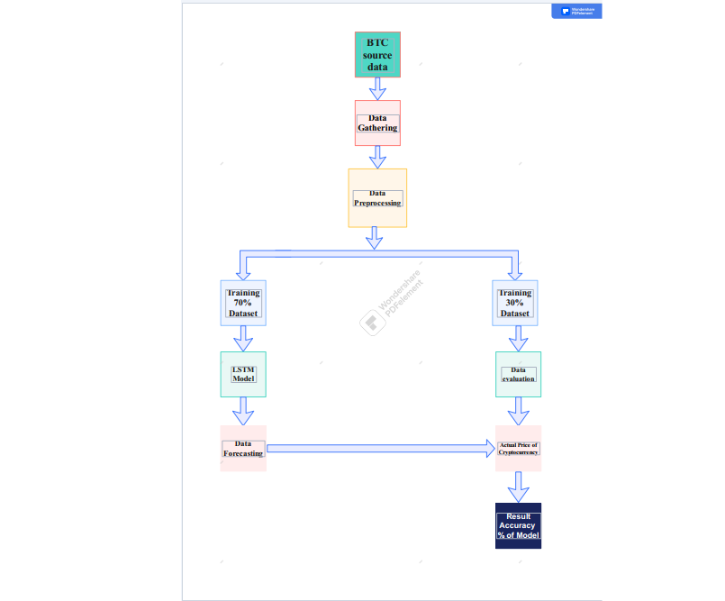



In the proposed model author has taken the Bitcoin dataset from the source. After downloading the dataset various operation like data normalization, data cleaning etc. performed which came under data preprocessing. Author divided the dataset into two parts Training - 70% of data and Testing - 30% of data. Author used two model for training i.e., LSTM (Long Short-Term Memory). They forecasted the predicted data from LSTM model using Matplotlib library. The forecasted data is compared with the testing dataset giving the actual cryptocurrency price. At last author calculated accuracy of each model. Author found the result of most efficient model as having more accuracy will be used.

**Chapter 2**

**INTRODUCTION OF LSTM MODEL**

**2.1 Hardware/Software requirements:**

1. Google Collab

2. Python Language Libraries- NumPy, Pandas, Matplotlib, Sklearn etc.

3. Libraries- NumPy, Pandas, Matplotlib, Sklearn etc.

**2.2 Introduction to Dataset:**

Cryptocurrencies are gaining popularity day by day, and their analysis is a fascinating and demanding research topic. The average daily trading volume of Bitcoin was $67 billion in May 2021. A peculiar feature of cryptocurrencies is that WE are not generally issued by a central authority, making them insusceptible to any governmental impedance. Cryptocurrency rates are closely related to news and influenced by tweets. However, no available dataset can analyze the crypto market adequately. We present a benchmark dataset for Cryptocurrency Price Movement Prediction based on historical prices. We also demonstrate use-cases by providing adapted baseline methods and a quantitative results analysis on our dataset.

We Have taken the data set from crypto compare.com it is a famous website for machine learning engineer to take data set for making machine learning models it has various range of data set of crypto currencies for example bitcoin, Litecoin, Ethereum, shibainu, dogecoin etc. we have taken bitcoin data set of 1 year 5 months approx. it consists of various parameters time, high, low, open, volume from, volume to, close here the time is showing date of the bitcoin prices. High is showing the highest price of bitcoin at that day, low is showing lowest price of bitcoin that day, and opening show where bitcoin last closed and that time, volume from means where the volume of start in bitcoin trade, volume to means where the end time of bitcoin were trade for which how much buyers and sellers is there. And for close means the last time of close the market of crypto. used api key to connect our data set to lstm model. In that way we can use dataset of any cryptocurrency using API keys from cryptocompare.com

All models we’ve built so far do not allow for operating on sequence data. Fortunately, we can use a special class of Neural Network models known as recurrent neural networks (RNNs) just for this purpose. *RNNs* allow using the output from the model as a new input for the same model. The process can be repeated indefinitely.

One serious limitation of *RNNs* is the in a sequence (e.g. Is there a dependency between today`s price and that 2 weeks ago?). One way to handle the situation is by using an **Long short-term memory (LSTM)** variant of *RNN*.

The default LSTM behavior is remembering information for prolonged periods of time. Let’s see how you can use LSTM in Keras.

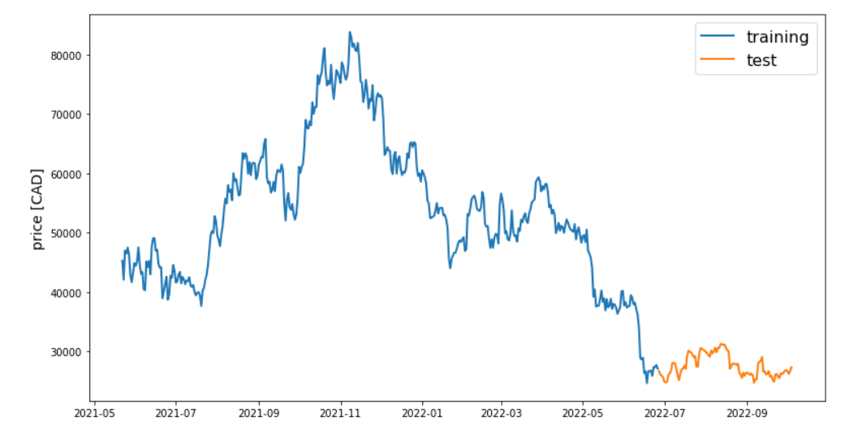

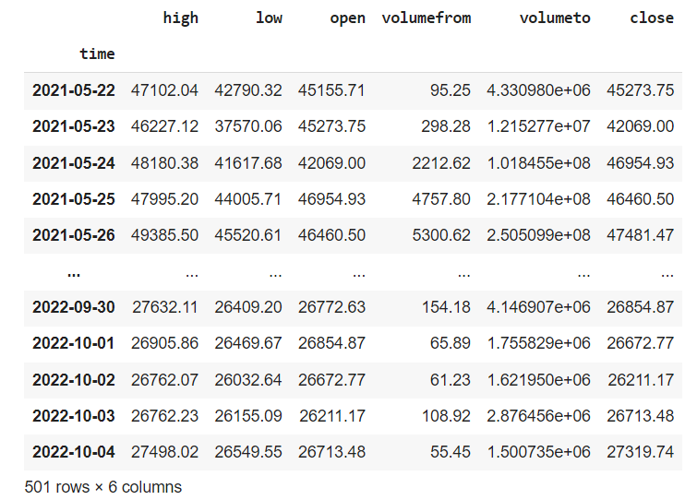

**2.3 Description of LSTM Model:**

Long short-term memory (LSTM) is an [artificial neural network](https://en.wikipedia.org/wiki/Artificial_neural_network) used in the fields of [artificial intelligence](https://en.wikipedia.org/wiki/Artificial_intelligence) and [deep learning](https://en.wikipedia.org/wiki/Deep_learning). Unlike standard [feedforward neural networks](https://en.wikipedia.org/wiki/Feedforward_neural_network), LSTM has feedback connections. Such a [recurrent neural network](https://en.wikipedia.org/wiki/Recurrent_neural_network) (RNN) can process not only single data points (such as images), but also entire sequences of data (such as speech or video). For example, LSTM is applicable to tasks such as unsegmented, connected [handwriting recognition](https://en.wikipedia.org/wiki/Handwriting_recognition), [speech recognition](https://en.wikipedia.org/wiki/Speech_recognition), [machine translation](https://en.wikipedia.org/wiki/Machine_translation), robot control, video games, and healthcare. LSTM has become the most cited neural network of the 20th century.

The name of LSTM refers to the analogy that a standard RNN has both "long-term memory" and "short-term memory". The connection weights and biases in the network change once per episode of training, analogous to how physiological changes in synaptic strengths store long-term memories; the activation patterns in the network change once per time-step, analogous to how the moment-to-moment change in electric firing patterns in the brain store short-term memories. The LSTM architecture aims to provide a short-term memory for RNN that can last thousands of timesteps, thus "long short-term memory".

A common LSTM unit is composed of a cell, an input gate, an output gate and a forget gate. The cell remembers values over arbitrary time intervals and the three gates regulate the flow of information into and out of the cell.

LSTM networks are well-suited to [classifying](https://en.wikipedia.org/wiki/Classification_in_machine_learning), [processing](https://en.wikipedia.org/wiki/Computer_data_processing) and [making predictions](https://en.wikipedia.org/wiki/Predict) based on [time series](https://en.wikipedia.org/wiki/Time_series) data, since there can be lags of unknown duration between important events in a time series. LSTMs were developed to deal with the [vanishing gradient problem](https://en.wikipedia.org/wiki/Vanishing_gradient_problem) that can be encountered when training traditional RNNs. Relative insensitivity to gap length is an advantage of LSTM over RNNs, [hidden Markov models](https://en.wikipedia.org/wiki/Hidden_Markov_models) and other sequence learning methods in numerous applications

**2.4 Diagram of LSTM Model**

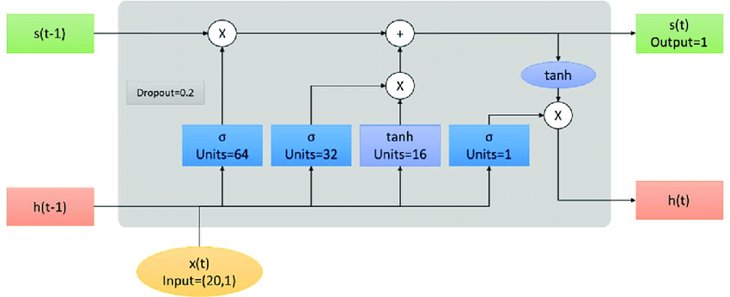

**2.5 Predicted Graph**

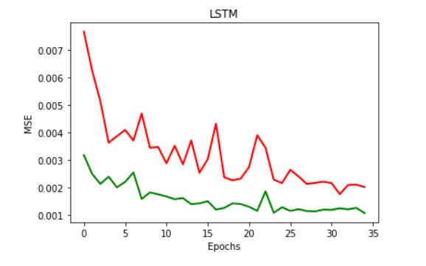

**2.6 Technical Code**

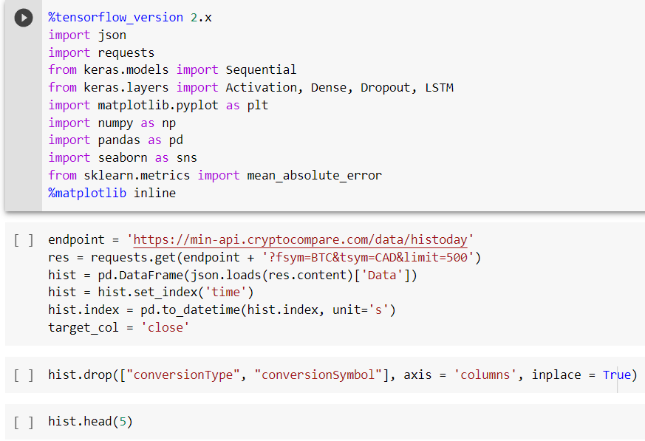

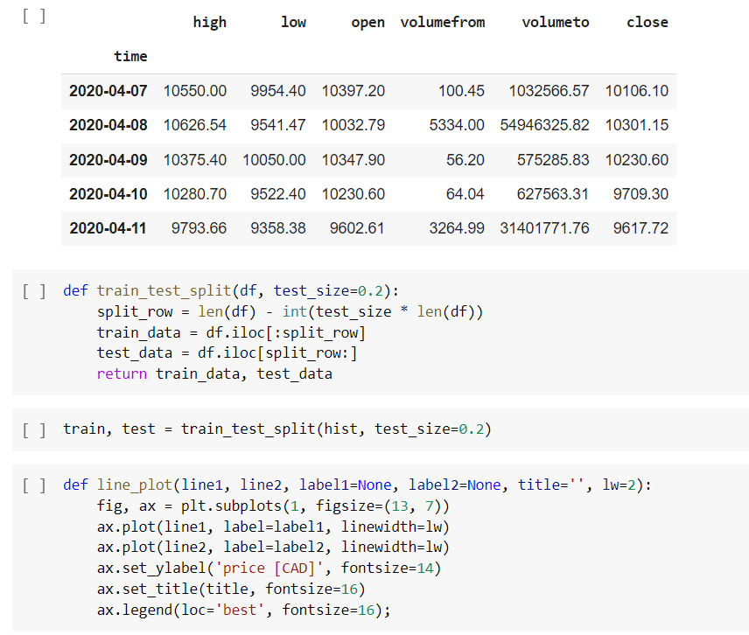



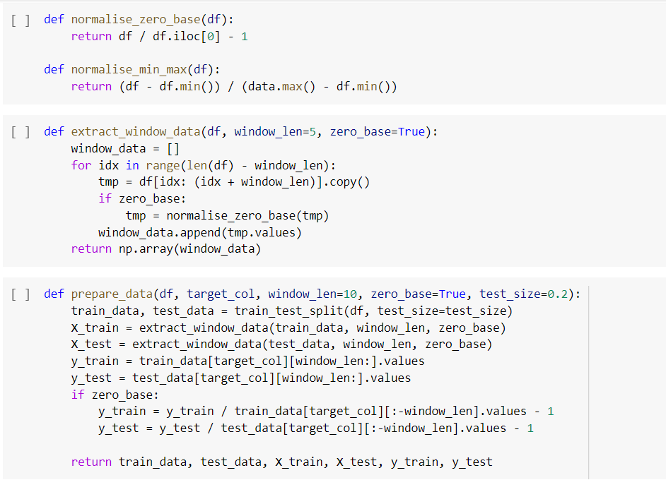

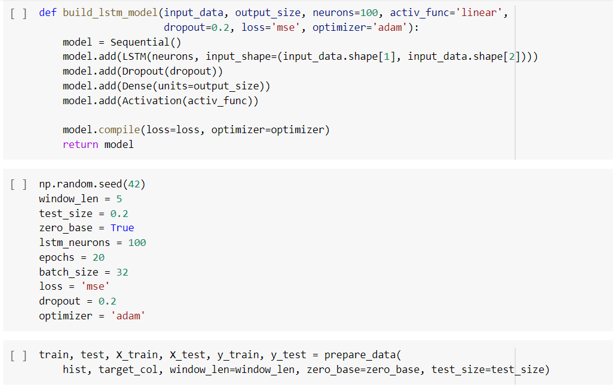

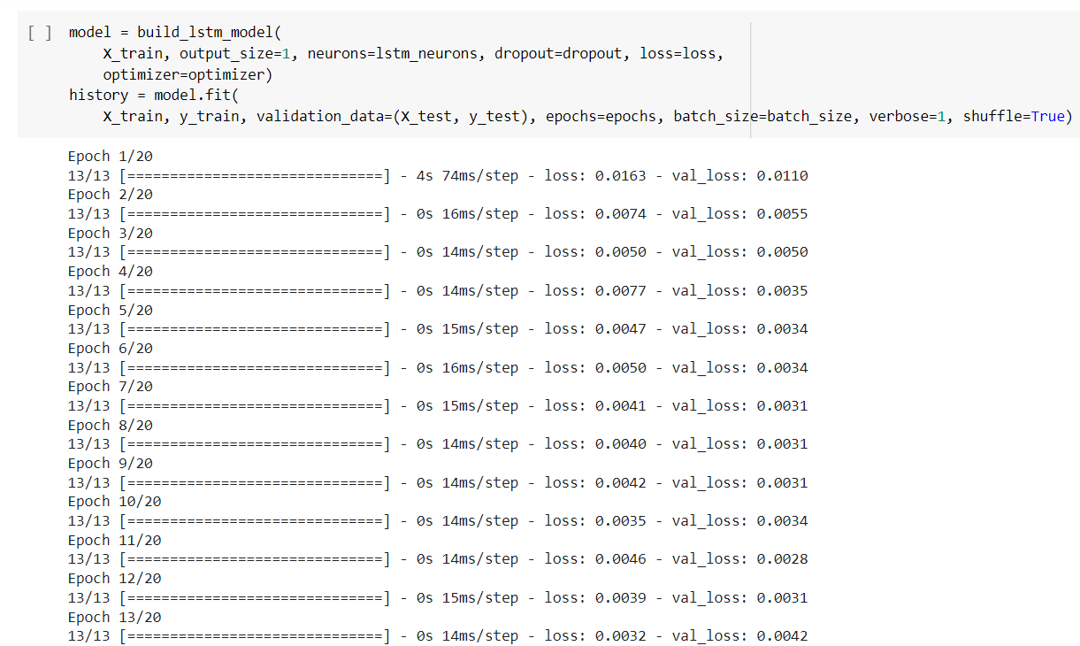

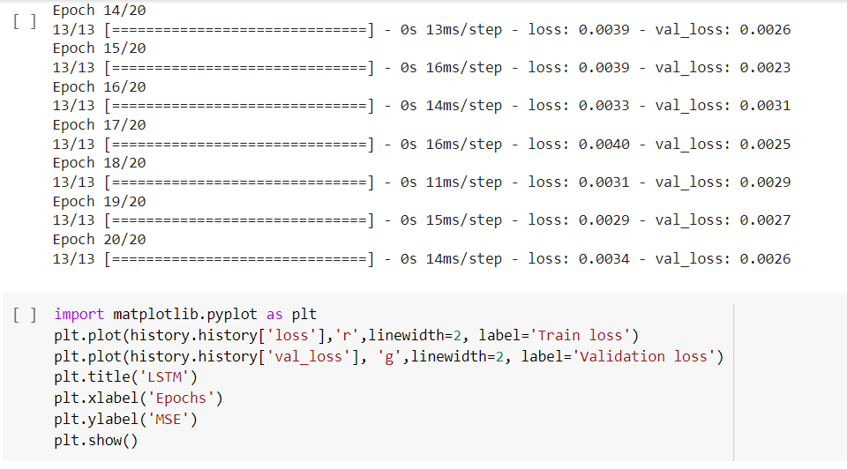

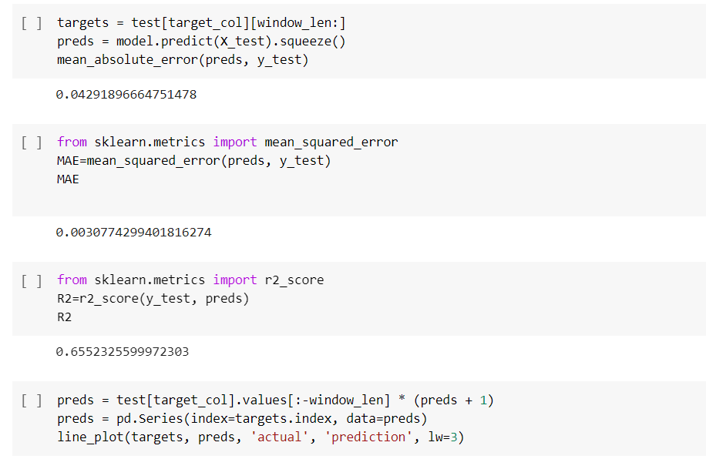

**Chapter 3**

**PROJECT OUTCOME AND APPLICABILITY**

**3.1 Code Outcomes**

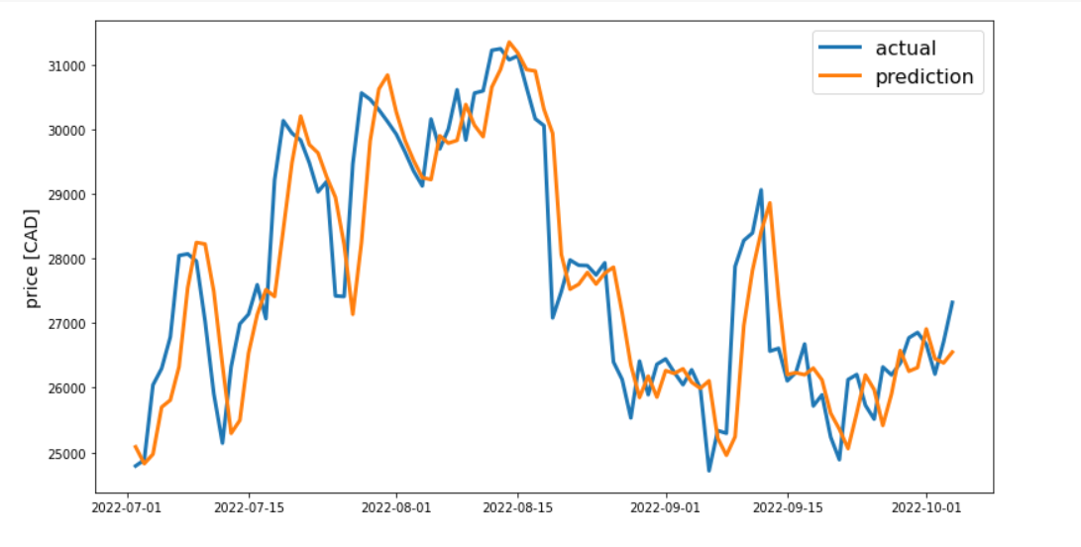

**Result Tables:**

|  |  |
| --- | --- |
| **Parameters** | **Values** |
| **Seed** | **42** |
| **Window_len** | **5** |
| **Test_size** | **0.2** |
| **Zero_base** | **True** |
| **Lstm_neurons** | **100** |
| **epochs** | **35** |
| **Batch_size** | **40** |
| **loss** | **‘mse’** |
| **dropout** | **0.2** |
| **optimizer** | **‘adam’** |

|  |  |
| --- | --- |
|  | **Value** |
| **MAE** | **0.02554982940364087** |
| **MSE** | **0.0011294702449779806** |
| **ACCURACY** | **0.7135908938100886** |

**3.2 Key Points about Code implementation**

Firstly, we have imported various libraries like NumPy and pandas for data preprocessing, matplotlib for expressing data in graphical format, sklearn for calculating accuracy of machine learning model. The we have taken the dataset from Cryptocompare.com which provide API keys. We generated and connected the API key to access the dataset in our code. Our Dataset is of approximately 1 Year 4 months. After that we divided the dataset into two parts training- 80 % and testing- 20 % expressing it in a graph.

we have tested and trained our data on LSTM (Long Short-Term Memory) model because it is most suitable for cryptocurrency prediction compared to other mode like GRU. Long short-term memory (LSTM) is a type of recurrent neural network (RNN) and powerful to model sequence data because it maintains an internal state to keep track of the data it has already seen. We have taken various parameters like batch size, activation function, drop loss, no of epochs, seeds etc. We have taken values of parameter which gives us the best accuracy for LSTM model i.e., seed-42, test size-0. 2, LSTM neurons -100, Epoches-35, batch size-40, dropout-0. 2, Optimizer-'adam'

We got our values Means absolute error -It measures the average magnitude of the errors in a set of predictions, without considering their direction. It’s the average over the test sample of the absolute differences between actual and predicted observations where all individual differences have equal weight.

I used Mean Absolute Error (MAE) as the evaluation metric. The reason behind choosing MAE over Root Mean Squared Error (RMSE) is that MAE is more interpretable. RMSE does not describe average error alone and hence is much more difficult to understand.

Mean square error-The Mean Squared Error measures how close a regression line is to a set of data points. It is a risk function corresponding to the expected value of the squared error loss. Mean square error is calculated by taking the average, specifically the mean, of errors squared from data as it relates to a function. The result we got is

**MAE- 0.02554982940364087**

**MSE- 0.0011294702449779806**

**Accuracy- 0.7135908938100886**

When we compared predicted prices from actual price using our testing dataset. We found it is showing less fluctuation means our prediction going in right direction.

We can improve our model accuracy as There is always space for improvement. The fuel of a neural network is data so we can build a more robust and accurate model by collecting more data. We can also try to adjust number of nodes in a layer or add additional LSTM layers. The things is that too deep in mind that it is not always good to increase the model accuracy because we may end up having an overfit model.

**Chapter 4**

**CONCLUSIONS AND RECOMMENDATION**

**4.1: OUTLINE**

This chapter of the report basically tells the reader that the report has come to an end. It also breaks down everything the report has discussed into more digestible chunks. It discusses the essential features and significant outcomes of the research. It sums up the key points of the discussion in the report, the essential features of the design or the significant outcomes of the investigation. Hence this chapter functions to round off the story of the project.

**4.2: EXISTING WORK WITH LIMITATIONS**

* There are some platforms available for this particular domain but their coin’s list is not dynamically kept up to date.
* Different features are available across various platforms which makes it uneasy for users to access the perfect choice to peruse.
* Since the feature representation of the items are hand-engineered to some extent, this technique requires a lot of domain knowledge. Therefore, the model can only be as good as the hand-engineered features.
* UX / UI of those platforms are not user understandable.
* Collaborative filtering totally depends on human ratings. Sparsity (Insufficient data), Scalability, Cold start problem (low accuracy)

**4.4: INFERENCES**

The application has wide options of further enhancements which will make it more useful and efficient, without compromising the usability and the interactive GUI.

**CONCLUSION**

E-learning, also known as online learning, is expanding in the market during the past few years and has attracted great attentions due to the lockdowns caused by COVID-19. E-learning has become an important way to acquire knowledge not only for students in schools and universities but also for life-long learners who seek improvement in their social life and workplace. E-learning provides online courses and learning resources under various categories such as computer science, mathematics and business. For example, Udemy provides users with courses, degrees, programs and certificates from top universities such as Stanford and Harvard and companies such as Google and IBM. Faced with various courses and resources, users need to figure out which course to take to help develop their own career and keep competitive in the global market. Therefore, it is crucial to develop recommender systems to support users in choosing courses, resources, or learning materials in E-learning.

E-learning systems fit into the ever-challenging situation and provide learners with remote learning opportunities and abundant learning resources. Facing with the numerous resources online, users need support in deciding which course to take, thus recommender systems are applied in E-learning to provide learners with personalized services by automatically identifying their preferences. This report had systematically discussed the main recommendation techniques employed in in E-learning and identifies new research directions. Three main recommendation techniques are reviewed: content-based, collaborative filtering-based and knowledge-based recommendations. The basic mechanism of these technique together with how they are used to fulfill the specific requirements in the context of E-learning had been highlighted and presented.

The observations in this paper could support researchers and practitioners to better understand the current development and future directions of recommender systems in E-learning.

**REFERENCE**

1. Valeria D’Amato, Susanna Levantesi, Gabriella Piscopo, Deep learning in predicting cryptocurrency volatility, Physica A: Statistical Mechanics and its Applications, Volume 596, 2022, 127158, ISSN 0378-4371, <https://doi.org/10.1016/j.physa.2022.127158>.

2. I. Nasirtafreshi,

Forecasting cryptocurrency prices using Recurrent Neural Network and Long Short-term Memory,

Data & Knowledge Engineering, Volume 139, 2022, 102009, ISSN 0169-023X,

<https://doi.org/10.1016/j.datak.2022.102009>.

3.Orçun Kaya, Mehdi Mostowfi, Low-volatility strategies for highly liquid cryptocurrencies, Finance Research Letters, Volume 46, Part B, 2022, 102422, ISSN 1544-6123,

<https://doi.org/10.1016/j.frl.2021.102422>.

4.Chun-Xiao Nie, Analysis of critical events in the correlation dynamics of cryptocurrency market, Physica A: Statistical Mechanics and its Applications, Volume 586, 2022, 126462, ISSN 0378-4371,

<https://doi.org/10.1016/j.physa.2021.126462>.

5.Inés Jiménez, Andrés Mora-Valencia, Javier Perote, Semi-nonparametric risk assessment with cryptocurrencies, Research in International Business and Finance, Volume 59, 2022, 101567, ISSN 0275-5319,

<https://doi.org/10.1016/j.ribaf.2021.101567>.

6.James Yae, George Zhe Tian, Out-of-sample forecasting of cryptocurrency returns: A comprehensive comparison of predictors and algorithms, Physica A: Statistical Mechanics and its Applications, Volume 598, 2022, 127379, ISSN 0378-4371,

<https://doi.org/10.1016/j.physa.2022.127379>.

7.[1] S. Singh, A computational method of forecasting based on high-order fuzzy time series, Expert Syst. Appl. 36 (7) (2009) 10551–10559.

[2] Q. Cai, D. Zhang, B. Wu, S.C. Leung, A novel stock forecasting model based on fuzzy time series and genetic algorithm, Proc. Computer. Sci. 18 (2013) 1155–1162.

8. R. Tahir, M. Huzaifa, A. Das, M. Ahmad, C. Gunter, F. Zaffar, M. Caesar, N. Borisov, Mining on someone else’s dime: Mitigating covert mining operations in clouds and enterprises, in: Research in Attacks, Intrusions, and Defenses - 20th International Symposium, RAID 2017, Atlanta, GA, USA, September 18-20, 2017, Proceedings, 2017, pp. 287–310,

http://dx. doi.org/10.1007/978-3-319-66332-6_13.

9.Barber, B., Lehavy, R., McNichols, M., Trueman, B., 2001. Can investors profit from the prophets? Security analyst recommendations and stock returns. The Journal of Finance 56 (2), 531–563.

<https://doi.org/10.1111/0022-1082.00336>.

10.Alonso-Monsalve, S., Suárez-Cetrulo, A.L., Cervantes, A. & Quintana, D. (2020). Convolution on neural networks for high-frequency trend prediction of cryptocurrency exchange rates using technical indicators. Expert Systems with Applications, 1491, Article 113250.

11.Aggarwal, R., Inclan, C., Leal, R., 1999. Volatility in emerging stock markets. J. Financ. Quant. Anal. 34, 33–55.

12. Wei Chen, Huilin Xu, Lifen Jia, Ying Gao, Machine learning model for bitcoin exchange rate prediction using economic and technology determinants, Int. J. Forecast. (2020)

http://dx.doi.org/10.1016/j.ijforecast.2020. 02.008, URL

<http://dx.doi.org/10.1016/j.ijforecast.2020.02.008>.

13. Akyildirim, E., Goncu, A., & Sensoy, A. (2020). Prediction of cryptocurrency returns using machine learning. Annals of Operations Research, 1–34.

14.Aboussalah, A. M., & Lee, C.-G. (2020). Continuous control with stacked deep dynamic recurrent reinforcement learning for portfolio optimization. Expert Systems with Applications, 140, Article 112891. <http://dx.doi.org/10.1016/j.eswa.2019.112891>.

15. Shahzad J, Bouri E, Roubaud D, Kristoufek L, Lucey B. Is bitcoin a better safe-haven investment than gold and commodities? International Review of Financial Analysis 2019; 63:322–330.

16.Ardia, D., Bluteau, K., Rueda, M., 2019. Regime changes in Bitcoin GARCH volatility dynamics. Finance Res. Lett. 29, 266–271.

https://doi.org/10.1016/j. frl.2018.08.009

17. Agosto, A. and Cafferata, A. (2020). Financial bubbles: a study of coexplosivity in the cryptocurrency market. Risks, 8(2):34.

18. Akyildirim, E., Corbet, S., Sensoy, A., Yarovaya, L., 2020. The impact of blockchain related name changes on corporate performance. J. Corp. Finance 65.

19. Rajat Kumar Rathore, Deepti Mishra, Pawan Singh Mehra, Om Pal, AHMAD SOBRI HASHIM, Azrulhizam Shapi'i, T. Ciano, Meshal Shutaywi, Real-world model for bitcoin price prediction, Information Processing Management, Volume 59, Issue 4, 2022, 102968, ISSN 0306-4573,

<https://doi.org/10.1016/j.ipm.2022.102968>

20. Gian Pietro Bellocca, Giuseppe Attanasio, Luca Cagliero, Jacopo Fior, Leveraging the momentum effect in machine learning-based cryptocurrency trading, Machine Learning with Applications, Volume 8, 2022, 100310, ISSN 2666-8270,

<https://doi.org/10.1016/j.mlwa.2022.100310>.

21. Matthias Schnaubelt, Deep reinforcement learning for the optimal placement of cryptocurrency limit orders, European Journal of Operational Research, Volume 296, Issue 3, 2022, Pages 993-1006, ISSN 0377-2217,

<https://doi.org/10.1016/j.ejor.2021.04.050>

22.Hamidreza Ahady Dolatsara, Eyyub Kibis, Musa Caglar, Serhat Simsek, Ali Dag, Gelareh Ahadi Dolatsara, DuSsrsun Delen, An interpretable decision-support systems for daily cryptocurrency trading, Expert Systems with Applications, Volume 203, 2022, 117409, ISSN 0957-4174,

<https://doi.org/10.1016/j.eswa.2022.117409>.

23.Faruk Ozer, C. Okan Sakar, an automated cryptocurrency trading system based on the detection of unusual price movements with a Time-Series Clustering-Based approach, Expert Systems with Applications, Volume 200, 2022, 117017, ISSN 0957-4174,

<https://doi.org/10.1016/j.eswa.2022.117017>.

24.Jiayue Wang, Runyu Chen, Wei Xu, Yuanyuan Tang, Yu Qin, A document analysis deep learning regression model for initial coin offerings success prediction, Expert Systems with Applications, Volume 210, 2022, 118367, ISSN 0957-4174,

<https://doi.org/10.1016/j.eswa.2022.118367>.